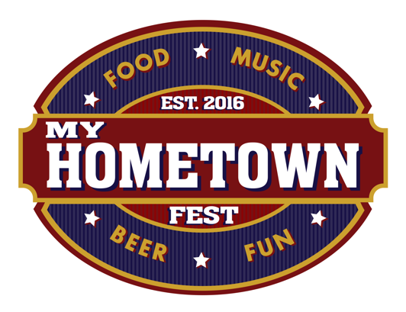
Vendor Information
Saturday, March 30th, 2024
Noon - 5 PM
Nathan Benderson Park
5851 Nathan Benderson Circle, Sarasota, FL
Vendor Responsibilities:
- Vendors are responsible for providing all equipment, tents, tables, electricity, generators, and branded signage etc. for their booths.
- All Vendors may hand out promotional items or offer other items for free or sale at their booth.
Food Vendor Responsibilities:
- Food vendors are expected to provide a MINIMUM of 500-1000 bite-sized samples of their featured food and may sell additional food or promotional items at their booth.
- Remember that samples do not have to be large. It is better to have smaller, bite-sized portions that last throughout the entire event than to run out of food early because your portion sizes were too large.
- If you run out of food, be sure and have something else to hand out. Business card or QR code.
Beer Sampling Booth Responsibilities:
- Beer sampling booths will be supplied a description of the beers they will be sampling from Gold Coast Eagle and will be asked to tell attendees about the beer they are sampling.
- Sample pours should be no more than 2.5 oz – this amount will be marked on the commemorative sampling cups provided for the event. Anything over 3.5 oz. may result in a violation from the Division of Alcoholic Beverages & Tobacco! Each beer sampling vendor will have 3 – 4 cases of each beer that they will be serving (usually 2 brands).
- Ice will be provided by a My Hometown Fest volunteer at no charge to vendors throughout the day in order to keep the craft beer cold. If you need more ice or craft beers at your station, please let our staff know.
- Wristbands and commemorative cups are required for sampling.

Booth Set up and Tear down:
- Friday, March 29th 2PM – 7PM. Please notify Tim Self if you wish to set up at this time by calling (941) 993-9036.
- Saturday, March 30th 8:30AM – 10:30AM – All Vendors should arrive within this time frame to set up their booth. Your assigned area will be given to you upon arrival and will be clearly marked in the event area. A My Hometown Fest volunteer will be present to assist you in locating your booth and assisting in set up, if needed.
- 11:00 AM – All non-essential vehicles must be moved to the designated vendor parking area.
- 11:30 AM – Vendors should be set up and ready to go
- Noon – Gates Open
- 5:00 PM – Gates Close
- AFTER 5:00 PM – Dismantling booths may begin. Please do not begin dismantling your booth before 5:00 PM!
- 5:15 PM – Or as soon as the general public has vacated the event area, vendor vehicles may be brought onto the venue grounds for loading and exit.
Vendor Banners & Signage
- Vendors should bring their own branded banners and signs and may display them in their designated area.
Beverage Sales – Sertoma Club of Sarasota
- Beer will be for sale during the event. Limited Soft Drinks will be available.
- Limited Water will be provided throughout the event. Vendors may distribute water at no cost, from their booth if they wish.
Restroom Facilities
- Restroom facilities are provided at the north end of the venue (southern base of the viewing tower) and south end of the venue (portalets).
Vendor Tickets
- Vendor tickets are available upon arrival at the venue. The ticket does need to be redeemed for the appropriate wrist band to participate in craft beverage sampling or beer purchases.
- ID is required to receive a “over 21” wristband.

Parking
- All parking will be provided at NO charge to vendors arriving BEFORE 11:00 AM. Vendors and their staff who arrive after 11:00 AM are subject to the $10/vehicle parking fee charged by Nathan Benderson Park. This fee goes to Benderson Park Park, not to Sertoma,
- Vendor Parking passes are available at MyHometownFest.com under Vendor Forms titled “Vendor Parking” Limit 2 per business. They will also be supplied upon arrival Friday and Saturday.
- Parking for all event attendees is $10/vehicle.
- Parking attendants will be on hand before, during and after the event to direct traffic.
- There will NOT be a designated vendor parking area. You will be directed where to park after you have delivered your booth materials.
On Site Security
- Onsite Security Services will be provided by My Hometown Fest. Some, but not all, will be armed. They will be in uniform and should be visible at all times. The Sarasota Sheriff’s Department will also have personnel on site.
Trash Service
- 24 large trash containers will be supplied by My Hometown Fest at various locations throughout the venue and will be routinely emptied throughout the day.
On Site Communication
- Several My Hometown Fest Volunteers will be carrying portable radios and can convey messages quickly throughout the venue.
Medical Emergency
- In the event that you or someone at your booth needs medical attention, please contact either security or a My Hometown Fest Volunteer immediately.
Thanks again for participating in this wonderful event and for supporting the work of Sertoma Club of Greater Sarasota and our Sertoma Kids Clinic!
It is going to be a great time!

